Unity Spiritual Center of Central Minnesota Board of Directors

Meeting Minutes

September 23, 2021

Opening
The regular meeting of the Unity Spiritual Center of Central Minnesota Board of Directors was called to order at 10:00 am on September 23, 2021 on Zoom by President Jeanne Borgstrom. After a prayer by Carol we read the Board Pledge.

Present
Present were Jeanne Borgstrom, Susan Holmen, Carol Laudenbach, Phil Limerick, Rebecca Marie, and Cristina Seaborn. Rev. Jim was absent, at the Regional Ministers’ Conference.
Secretary’s Report
The Minutes for the Working Board Meeting on 9/9/21 were previously approved through email and the Secretary’s report was approved.

Treasurer’s Report
Phil explained that the August financial report is not ready yet. We have moved to the new ICON system and he and Sanda are working with Connie at ICON to learn and become fluent in the system. Now all financial operations (accounting, payroll, financial giving reports, etc.) are all in ICON. Phil, Sanda and Rev. Jim will be walking through it to:
- ensure it does what we want/need
- figure out who will do what (Rev. Jim, Phil and Cheryl will all have access to it))

Minister’s Report (see attached)
Our Sunday service will move to 11:00 am starting October 3, since we have permission from BLC to get in at 10 am. Attendance has declined some.

Also, COVID numbers have become very high again. Phil explains the state of MN trends, from a 7-day average of 473/day on 7/31, to 1558/day on 8/31, and 2374/day on 9/21. We probably need to establish a new threshold for making the decision to no longer meet in person but return to Zoom. A booster from Pfizer has been approved for anyone 65 and older, and high-risk persons. The Delta variant is highly contagious. When Rev. Jim returns from the Regional Conference he will have more up-to-date information.
President’s Report
Jeanne shares a list of items for the Board to be thinking about, preparing or discussing (see attached). An Annual Review of Rev. Jim is planned for October, along with a review of the Board’s work and performance. At the October working meeting we can decide on the format for both reviews. Carol has previously sent self-evaluation forms and it is suggested she do so again. There could also be a minister self-evaluation form Rev. Jim can complete.

We also discussed the feasibility of having outdoor social gatherings this fall. Many venues are closing for in-person again due to COVID. It is agreed we will cancel any outdoor events and focus on getting established in a new home. We need to let the congregation know about this decision and will request that Rev. Jim make this announce and get something to Cheryl for the newsletter. Saying it in a “gentle” way is advised. There is also discussion of how else to put this information out to congregants and it is agreed that Susan and Rebecca will work with Cheryl on a mailing next week.

It is again time to prepare for the Annual Meeting, starting with the Nominating Committee. JoAnn Pelinka was elected to initiate that committee this year, but it is possible she no longer will be doing that. Susan will reach out to her to find out her plan. Jeanne suggests that all Board members be prepared to discuss their desire/plans for continuing on the Board, for the November meeting. Jeanne and Rebecca’s terms will be complete; Susan and Phil have one remaining year, and Carol and Cristina have two more years. All agree that suggestions for potential nominees can be generated.

Jeanne brought up the idea of a Bereavement/Grief/Healing Ministry or sub-ministry. She will share more about this in October. Also, Rev. Jim has suggested forming a Financial Ministry, to handle tasks related to decision-making and accounting responsibilities.

Sacred Service
The Sartell Craft Fair is scheduled for Saturday, October 30th. Rebecca will take the lead on that. We are no longer in Sartell, so it is not clear if we can be involved, and with COVID and our having no space to bake in, we know it must be handled differently. Rebecca will investigate the options.

Unfinished Business
Phil gives an update on the liability insurance policy requirements. We have clarified that because they mostly relate to child safety, and we have no children’s program, nor are we in a permanent space with childcare, we do not need these policies at this time. The rider will be removed until we are in permanent space. Our focus will now be on creating a harassment policy and an “objectional behavior” policy when there is time.

Spiritual Center Task Force Charter
Carol shares the Spiritual Task Force Charter draft for discussion, as well as descriptions of the roles of Team Lead and Board Liaison/Champion (see attached). There is a Task Force Kick-off scheduled for Wednesday, 9/29 at 10 am, on Zoom, for all potential team members as well as Board members. The community is welcome to attend as well, through the newsletter. It is agreed that Carol will be the Board Liaison, and the Team Lead will be decided at the Kick-off.

A motion is made to accept the Charter (with Carol added as Liaison), as well as accepting the Roles document. The description of roles will also be utilized with future new teams that create a charter. The motion is passed.

Next Meeting
An added Board Meeting is scheduled for Thursday, September 30, at 10:00 am for one hour, to complete the Business tabled at this meeting and to update Rev. Jim. As it is a fifth Thursday in the month, Susan will request that Cheryl schedule that.
The next Working Board Meeting is scheduled for Thursday, October 14 at 10 am, and the next regular Board Meeting will be held on Thursday, October 28, at 10:00 am, both on Zoom.
Tabled Discussions or Tasks
Office Administration Position 2 Motion
Regional Board Training Proposal
Survey Monkey Evaluation for classes

Adjournment
Jeanne adjourned the meeting at 12:05 pm with a prayer by Rebecca.

Minutes respectfully submitted by: | Susan G Holmen
Approved by: | Board

Minister’s Report – Rev. Jim Ernstsen
September 23, 2021
- Completed
  - COVID Report has been updated – New Case numbers have climbed from 75 in July to 2160
  - Summer series: “Summer of Butterworth” has completed
  - Website development fee has been paid to OneEach Technology
  - Pride in the Park 2021 was a huge success with hundreds of people visiting our sponsor tent
  - Accounting contract signed with Icon Accounting - $275 / mo
  - Most marketing materials have been updated with new logos
  - World Day of Prayer – Taizé Service Sept 9th – 20 attendees
  - Outgoing tithe calculation has been amended to include gift to BLC for Peace Hall discount
  - The Marketplace office lease runs through Nov 30. We can have an additional 3 mo: Dec/Jan/Feb
  - Rev. Lisa Herklotz has been granted UCM member status
- Ongoing
  - New Website work has begun by SaraM
  - Accounting restructuring continues
    - New Processes & Flows to be completed
    - New bookkeeper position is recommended
  - Organizational/Ministry Chart continues with Rebecca & Carol
  - Revs. Jim & Lisa attending Unity Great Lakes Regional Conference (Sept 20-23rd)
  - Loaves & Fishes Fund has been submitted… waiting for reply
  - Rev. Lisa Herklotz will be guest speaker on Sunday Sept 26th
  - CherylP facilitating “Even Mystics…” prosperity class
  - An “Open Projects” list now exists in the UCM Sandbox. Process details TBD.
- New
  - Sunday Service will change times to 11am at BLC beginning Oct 3rd
  - A new Spiritual Center Task Force is being formed. Kickoff meeting is Sept 29th @ 10am
  - Fall Book Series begins Sept 29th, five Wednesdays & four Sundays… The Four Agreements
  - Recommending to the Marketing Team that we include photos of board, Prayer Chaplains, Staff, +
  - Full access to the Icon Church Management System has been given to Phil, Cheryl, Rev. Jim
  - Will move accounting files from laptop (in Sanda’s possession) to the OneDrive cloud
  - Adult Enrichment in November: Gratitude
  - Adult Enrichment in December: Metaphysical Christmas
- Open Action Items
  - This section has been moved to the UCM Sandbox and will no longer be duplicated here.

- Ministries reporting to the Minister
  - Adult Enrichment – Carol
  - Prayer Chaplain – Cheryl
  - Marketing & Media – Sara
  - Sacred Service – Rebecca Marie
  - Board Leadership – Jeanne & Carol
  - Accounting & Finance – Phil
  - Greeters – Monique
  - Spiritual Social Action – Susan & Michelle
  - Sunday Service & Technology – Cheryl

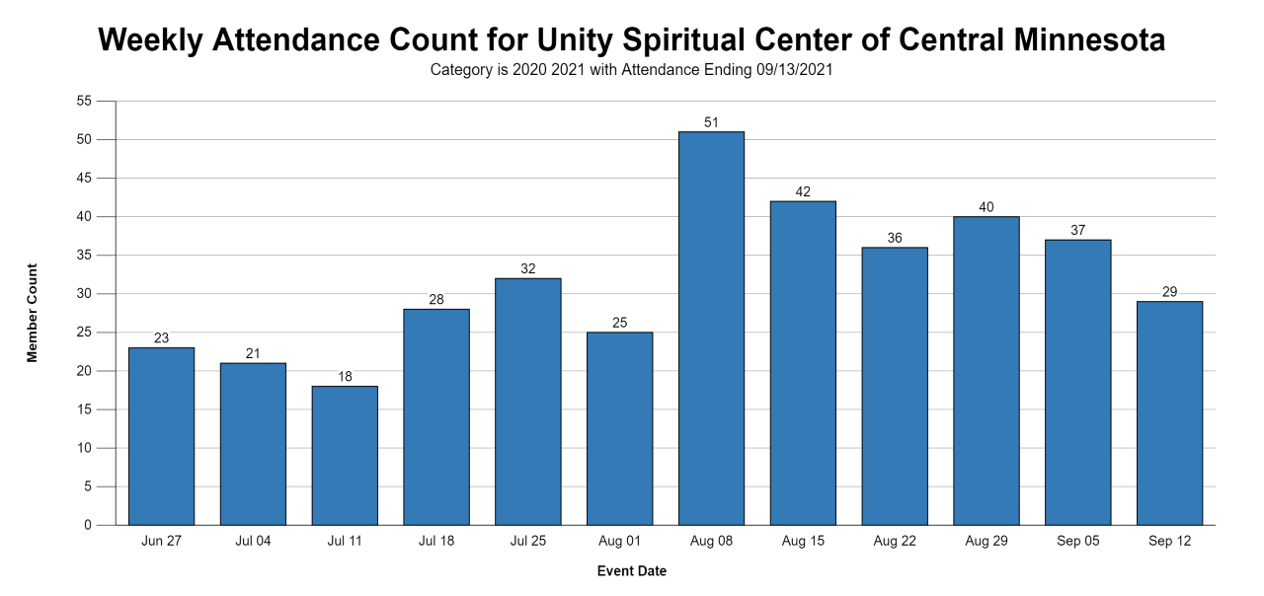
Attendance graph:

Motions (with a board vote):
- Motion to hire a second Office Admin (see attached motion)
- Motion to approve Spiritual Center Task Force (SCTF) Charter changes (see attached Charter)

Proposals (non-voting items):
- Proposal to accept invitation to attend Free Regional Board Workshop (see attached flyer and proposal)
  - Looking for a commitment from three other members to attend on Saturday Oct 30th

Presidents Report-Jeanne Borgstrom
Board Meeting Thursday 9/23/21
Things to be thinking about/preparing for/discussing:

- Sunday Service new time change beginning October 3
  - Who is changing the social media, newsletter, post card mailing again?

- Rev Jim Annual review
  - Prepare and conduct in October 14, working meeting?

- Board evaluation of the year’s work
  - Carol to lead-October/November working or regular meeting
  - Schedule for 2022

- Outdoor social/potluck gathering this fall
  - Feasibility due to timing and covid numbers advancing?

- Nominating team
  - When to form – By Laws specify 60 days prior to annual meeting.
  - Who is the Chair- according to the Minutes JoAnn Pelinka was nominated to be the 2021 nominating committee chair.
  - By Nov board meeting each board member will be asked to state their desire to continue in what capacity or not. At present, Jeanne and Rebecca are up for new 3 year term; Phil and Susan each have one year remaining, and Carol and Cristina have 2-year terms remaining.
  - Generation of nominee suggestions by current board

- Bereavement/Grief/Healing ministry formation
  - Discussions in October?
  - Sub-ministry reporting to Minister or Prayer Chaplain Ministry

- Formation of a Finance Ministry –October/November?

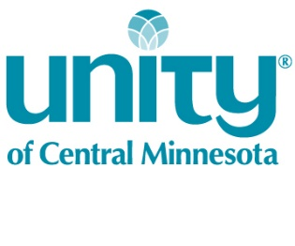
Spiritual Center Task Force Charter
September 2021

The Unity of Central Minnesota Board of Directors has authorized a Spiritual Center Task Force to meet regularly for the purpose of identifying our spiritual purpose as a center and making a recommendation for a long-term meeting space that reflects that purpose. The output of this Task Force will include:
- Identification of our “Calling”¹ as Spiritual Center
  - The discernment process will produce a single “Calling Statement” that may include up to three spiritually focused directions
  - The “Calling Statement” will support the Mission and Vision Statements of UCM
- A list of 3 or 4 physical meeting spaces that satisfy the identified spiritual calling

- The task force will present the “Calling Statement” to the board on or before the October 28th, 2021 board meeting.
- This task force will present its meeting space options to the Board of Directors by Dec 23rd, 2021.

The lead member of this Task Force is ______to be determined at the 9/29 Kick-off meeting______.
The board liaison for this Task Force is ______Carol Laudenbach ______.
The budget cap for this Task Force is ____$100_______.
Checkpoints for this Task Force will be ___weekly updates to the board through the liaison____.
The Spiritual Center Task Force is a temporary body that will be released upon completion of its recommendations to the Board.
Description of the history, background, or reason for the Task Force may be included in this OPTIONAL space:
Unity of Central Minnesota is seeking its next long-term meeting space. This task force follows the work and output of the Visioning Task Force earlier this year. The Visioning document created by that Task Force, our Mission Statement, and our Vision will serve as inputs to the “Identification of our Calling” process. That discernment process will move us from our heads to our hearts. The task force is also instructed to avoid specific physical attributes to a meeting space. The task force will ask itself questions such as “who do we want to be?” or “what is our calling as a spiritual center?” This task force will communicate regularly and often with the board. The board and/or minister will then communicate progress or decisions to the congregation.

¹Calling: an inner impulse toward a particular course of action especially when accompanied by conviction of divine influence.
- A Calling is a direction rather than a physical attribute
- A Calling is the work of spiritual discernment
- A Calling supports the Mission of the Spiritual Center
- A Calling is NOT a physical thing that you can touch
- Examples:
  - Our Spiritual Calling is to be a change agent for Spiritual Social Action in our local community
  - Our Spiritual Calling is to be an educational center for Unity Truth principles
  - Our Spiritual Calling is to be an inclusive social meeting place for progressive families in the Central Minnesota area
  - Our Spiritual Calling is to be a loving group of individuals that focuses on traditional service to one another
  - A Spiritual Calling is NOT: a great location, the perfect size, a list of “must have” physical attributes

Identify a spiritual “Calling” using a discernment process
Spiritual Center Task Force

Start
Input: Vision Doc

Input: Mission Statement

List 3 or 4 spaces that satisfy the spiritual “Calling”

Spiritual Center Future Task Force Roles
Background: During the discussion of the Spiritual Center Future Task Force during our last meeting, I heard different assumptions voiced about the roles of Team leads and the Board Liaison.
I put together this list of the roles of each of those positions for your review and input.

Team Lead

- Recognizes the work of the team as a Spirit filled endeavor. Begins and ends each meeting with prayer.
- Establishes group communication and expectations through heart agreements, setting group boundaries.
- Schedules meetings; maintains such records of the Team work as is necessary to move forward efficiently.
- Is familiar with the expectations in the Team Charter.
- Communicates expectations to team members.
- Identifies skills and strengths of Team members to advance the work of the team; seeks leaders within the team as is appropriate to each task or set of requirements and empowers them to perform.
- Leads/assists the team in identifying the means and methods to be used to meet the outcomes identified in the Charter.
- Brings concerns to the Board liaison; brings requests for modification to the Charter to the Board liaison.
- Communicates with the Board liaison regularly.
- Takes steps to assure the outcomes are delivered by the date set in the Charter and in the form identified in the Charter.

Board Liaison Team Champion
- Leads an initial meeting with the Team.
- Assures Team Lead is familiar with the expectations in the Charter.
- Monitors progress of the Team.
- Attends meetings of the Team or sub-groups of the Team.
- Reports progress to the Board in writing on the schedule identified in the Charter.
- Brings concerns or requests for changes to the Charter in writing to the Board.
- Brings concerns of the Board to the Team in writing.

